**Lab#1- Heat Treating/Microstructures/Properties of Steels**

Edward McGarry

10/16/2019

Alec Anderson, Colin Arbuthnot, Garrett Marlowe

MSE3333 Thursday 3p.m.

**Abstract**

Nine samples of steel of three different compositions—1018, 1045, and 4340—were given three different heat treatments—air-cooling, water-quenching, and tempering—to observe the effects of differing heat treatments on steels. Ferrite forms more readily in low-carbon steels and is the softest of all the microstructures. Pearlite forms off the ferrite and is harder. Bainite is harder than pearlite, and martensite is the hardest off all. In each case, the air-cooled version of each steel was the softest, tempered was in the middle, and water-quenched was the hardest. 1018 was the softest steel in all heat treatments due to its low carbon wt.% preventing pearlite and martensite from forming readily and promoting the formation of ferrite. 1045 was the intermediate steel in terms of hardness due to its high carbon content, which allows for more pearlite and martensite to form. 4340 was the hardest steel after every heat treatment because the alloying elements suppress the formation of ferrite and pearlite, which leads to martensite forming in even the air-cooled sample. 1045 and 4340 water-quenched were close in hardness, 40C and 40.2C respectively, due to high amounts of martensite and a similar carbon content.

**Introduction**

There are multiple different ways to strengthen steels: solid solution strengthening, cold working, precipitation hardening, grain refinement, and phase transformation. The experiments done in this lab focus on phase transformations, as heat treatments change strength and toughness of steels while retaining chemical composition and shape of a sample. Different types of steels and their different cooling rates influence the microstructure. This changes the strength of the steel by effecting the relative amounts of ferrite, pearlite, bainite and martensite in the microstructure. Three different steels were chosen for this lab:1018, 1045, and 4340. 1018 and 1045 are plain Carbon steels with 0.18 wt.% C and 0.45 wt.% C respectively. 4340 is a steel alloyed with 1.75 wt.% Ni, 0.75 wt.% Cr, 0.33 wt.% Mo, along with Mn and Si. Three different cooling methods were selected: air cooled, water cooled, and tempered. This allows for nine samples total, each with their own alloy composition and cooling rate. Every sample was cooled from a starting point of 950°C to room temperature, except the tempered, which was reheated to 450°C for 15 minutes before being quenched again. This lab serves to observe the impacts of cooling rates on multiple steels and their impacts on macrohardness and microstructure.

Under equilibrium conditions, only ferrite, pearlite, and bainite can form; however, when there is a fast enough cooling rate martensite will form. The diffusion of Carbon out of the austenite does not have enough time to take place and the Carbon becomes trapped. A strong, yet brittle microstructure is formed as a result. The three microstructures focused on in this experiment are ferrite, pearlite, and martensite. Ferrite contains 0.02wt.% C, pearlite more, and Martensite contains the most. As a steel cools these microstructures form and depending on the steel’s cooling rate and wt.% C a specific fraction of each will be had. Ferrite is the softest microstructure, followed by pearlite in the middle, and martensite is the hardest. According to this, as the amount of ferrite decreases, and the amount harder microstructures increases the metal should become harder. This can be impacted by increasing the amount of carbon or decreasing the amount of time diffusion can occur by cooling the steel faster.

The hardness of steels is a measure of how well the material resists local deformation, or more specifically, how much resistance there is to plastic flow. Rockwell C and B were the selected scales for this experiment. This allows for the hardness of each sample to be measured, which can give a good insight into how cooling rates and alloying elements can impact the hardness of a steel. The samples only need to be ground to remove mill scale and have flat edges for this step as Rockwell hardness testing is a macrohardness test. Rockwell C should be primarily used. If a Rockwell C of less than 20 is read, Rockwell B should then be selected. Ideally, tensile strength specimens would be selected and used for this experiment, however, the non-destructive nature of using macrohardness data, which is related to tensile strength, allows for multiple hardness readings on the same sample. This also allows the same specimen to be used in both the hardness tests and the microscopic viewing portions of this experiment.

In order to view the microstructure to see all the microstructures that are present, sanding, polishing, and etching must take place. The sanding and polishing serve to make the surface as flat as possible. Etching is basically controlled corrosion that corrodes certain microstructures more than others. This allows for a distinct difference between the microstructures to be visually seen under a microscope with enough magnification. Using the etching procedure in this experiment, the main three microstructures, ferrite, pearlite, and martensite, can be identified. After identification has taken place, their relative amounts can be estimated and compared to their hardness data, cooling rates, and alloying elements. All of these factors play a large role in the hardenability and hardness of a steel, and are looked at in-depth throughout this report.

**Procedure**

Three samples each of 1018, 1045, and 4340 steel were obtained, making nine samples total. Any size or shape of the samples was acceptable if there was enough area for examination, but not too large to inhibit mounting. All nine were heated to 950°C for 15 minutes. One of each type of steel was air cooled to 200°C and the time to reach that temperature was recorded. One of each type of steel was water quenched to 100°C and the time to cool was recorded. The final three samples were water quenched, heated back up to 450°C for 15 minutes, and quenched again. The samples were then gathered and brought to a grinder. The oxide layer was then removed on all nine samples. Macrohardness testing then took place using the Rockwell B/C scale. Three readings were taken for each sample and then averaged. Mounting for all nine samples took place next. Bakelite was used in this Laboratory experiment. After mounting, the samples were ground down to 600 grit to prepare for polishing. The samples were then polished up to 6 micron, and then a final polish was applied. Etching took place next to allow the microstructures to become visible under the microscope. Micrographs were taken with the 10x and 50x objective for all nine samples. The structures were then analyzed using the view from the microscope, using the data gathered during this lab, and the relevant CCT diagrams using the cooling times recorded earlier.

**Results**

The etchant used allowed the microstructures to be differentiated from one another under the microscope. Martensite was made the darkest, pearlite was made a lighter color, and the other microstructures – ferrite, bainite, and untransformed austenite – remained white. Ferrite forms at the grain boundaries if there is enough time for carbon to diffuse out of the grain, and off the ferrite is where pearlite forms if given enough time. If the steel is rapidly cooled and diffusion cannot take place then martensite will form, and in some cases untransformed austenite will remain after quenching.

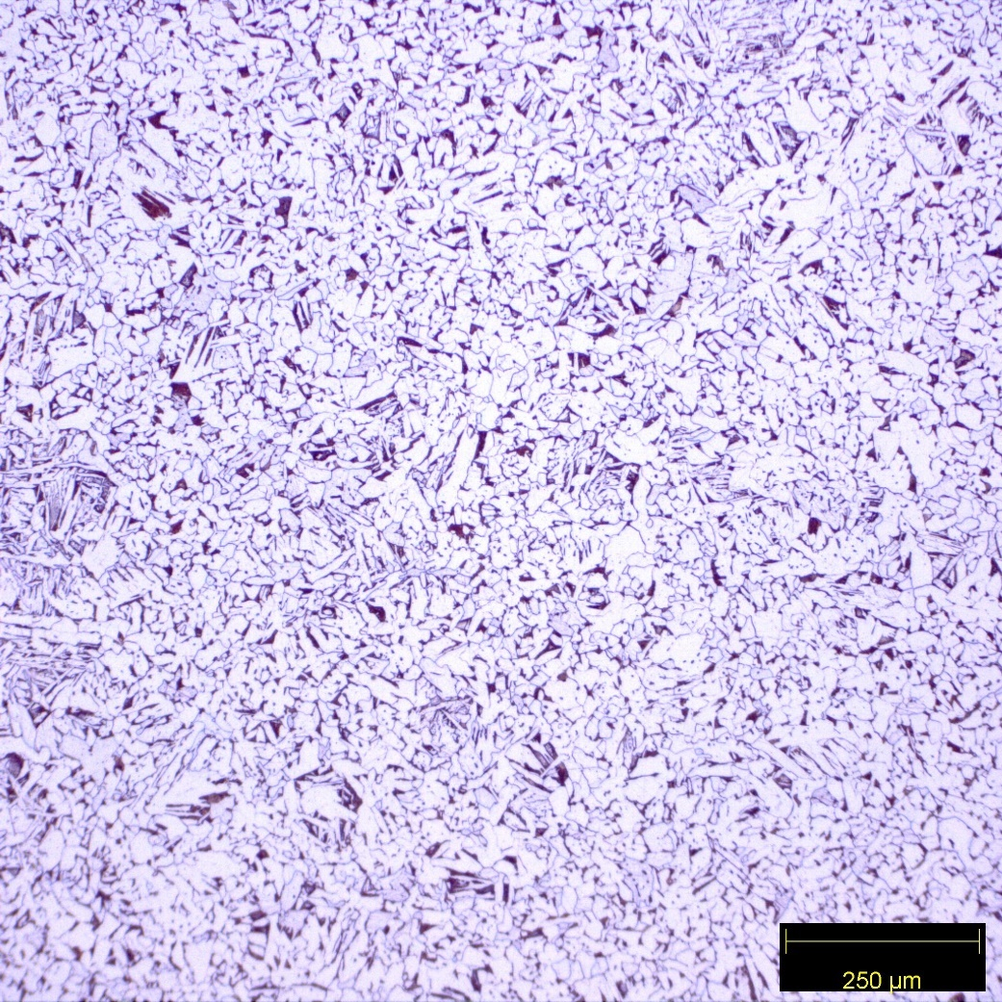

*Figure 1: 1018 air-cooled using the 10x objective.*

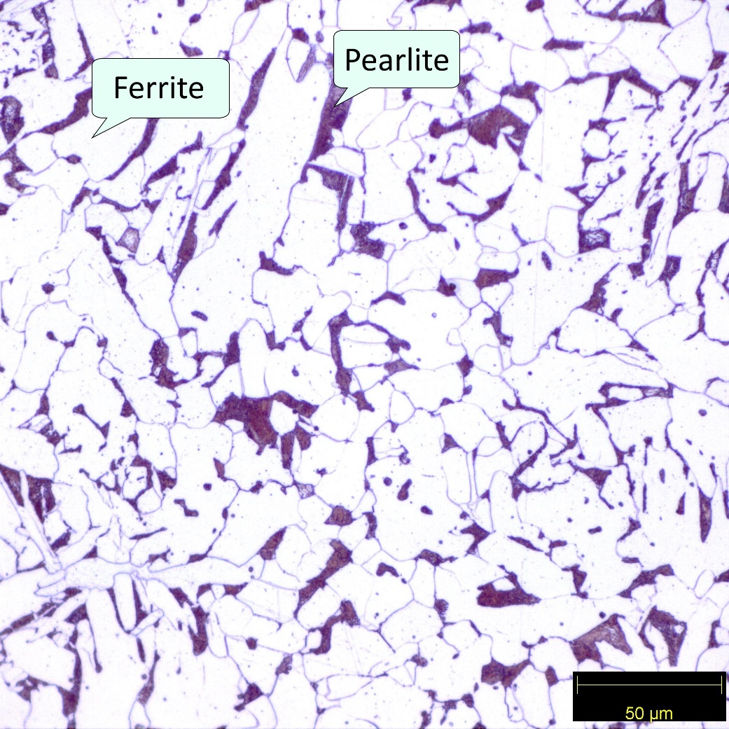

*Figure 2: 1018 air-cooled using the 50x objective. The white color indicates ferrite, and the dark color indicates pearlite.*

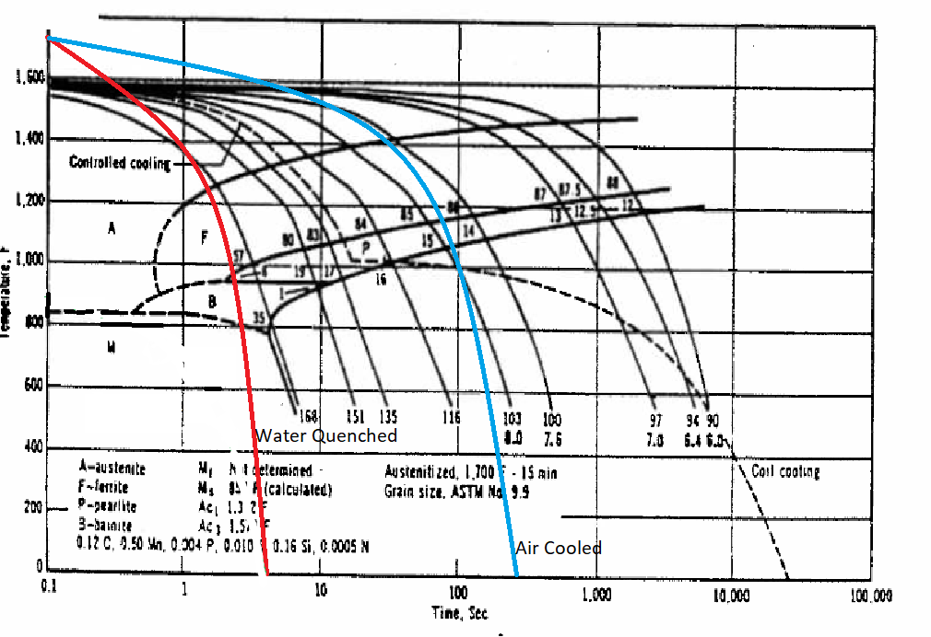

*Figure 3: CCT diagram for 1018 steel with constant cooling curves for air-cooled, quenched, and tempered samples.*

|  |  |  |  |  |  |
| --- | --- | --- | --- | --- | --- |
| Steel Sample | Cooling Method | Trial 1 | Trial 2 | Trial 3 | Average Hardness |
| 1018 | Air Cooled | 65.5 | 69.5 | 70.5 | 68.5 B |
| Tempered | 93.5 | 94 | 95.5 | 94.3 B |
| Water Cooled | 23.5 | 28 | 31 | 27.5C |
| 1045 | Air Cooled | 89 | 85.5 | 90 | 88.2 B |
| Tempered | 27 | 30 | 26 | 27.7C |
| Water Cooled | 41 | 41.5 | 37.5 | 40C |
| 4340 | Air Cooled | 29.5 | 31 | 28.5 | 29.7C |
| Tempered | 34.5 | 34.5 | 34.5 | 34.5C |
| Water Cooled | 41 | 40 | 39.5 | 40.2C |

*Table 1: Hardness data for 1018, 1045, and 4340 steels*

The 1018 air-cooled steel consists of ferrite and pearlite, with the ferrite in the white and the pearlite in the dark (Figures 1 and 2). The 1018 CCT diagram with a 313 second cooling rate corroborates this data (Figure 3). The hardness data also agrees with an average hardness of 68.5 Rockwell B (Table 1).

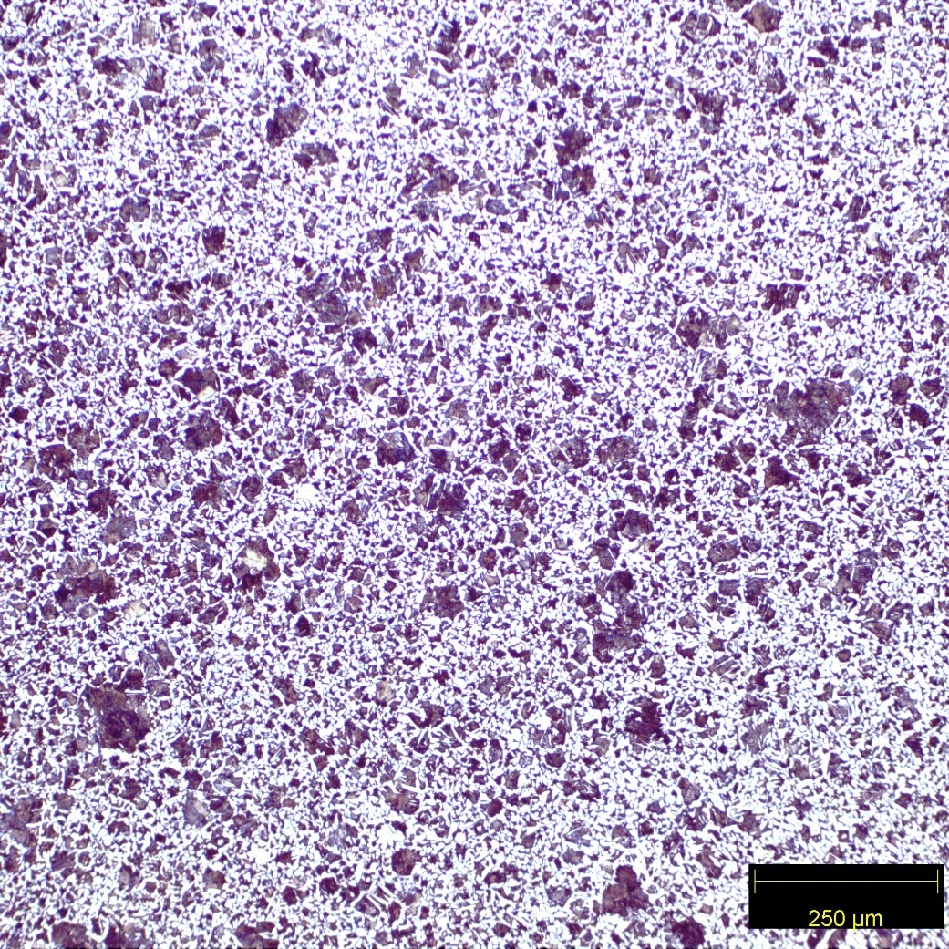

*Figure 4: 1045 air-cooled using the 10x objective.*

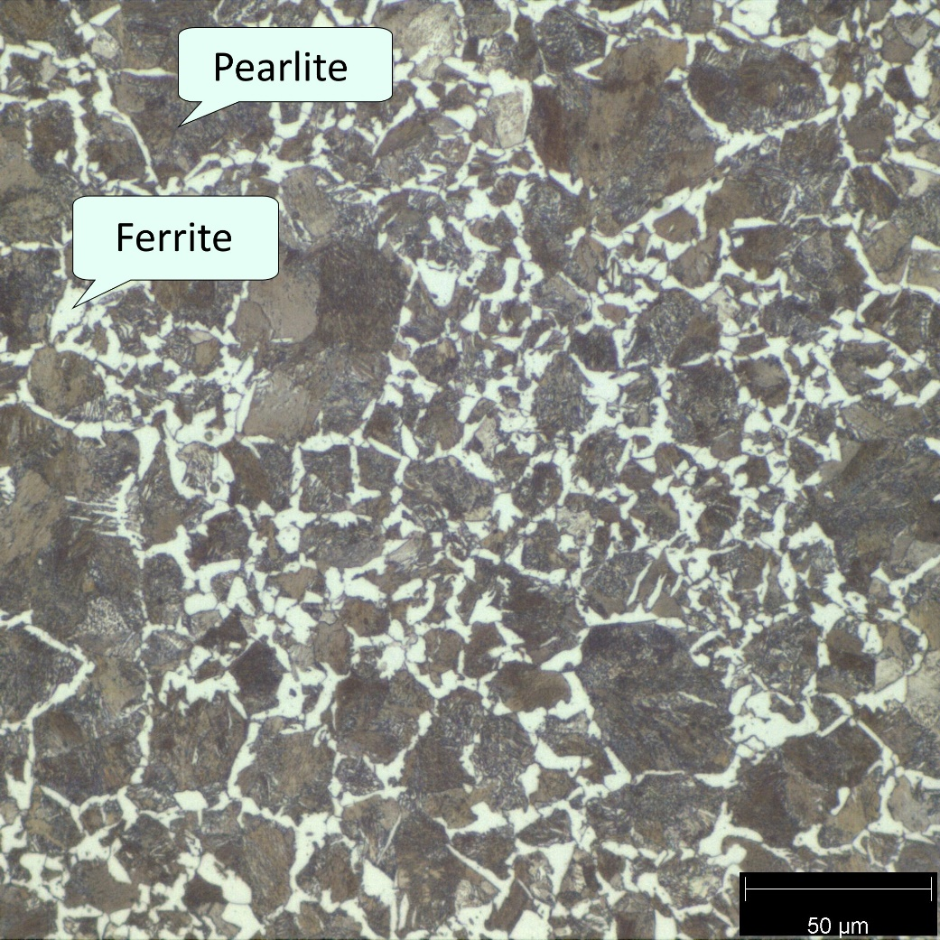

*Figure 5: 1045 air-cooled using the 50x objective. The light color indicates ferrite, and the dark color indicates pearlite.*

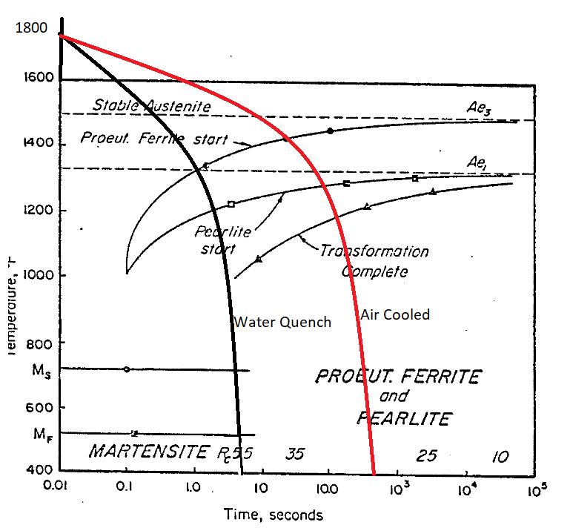

*Figure 6: CCT diagram for 1045 steel with constant cooling curves for air-cooled, quenched, and tempered samples.*

The 1045 air-cooled has ferrite and pearlite present based on the two microstructures seen in the micrograph (Figure 4 and 5). The 1045 CCT diagram with a 313 second cooling rate and hardness data agree with these findings (Figure 6 and Table 1). The hardness data average of 88.2 Rockwell B agrees with what microstructures are present (Table 1).

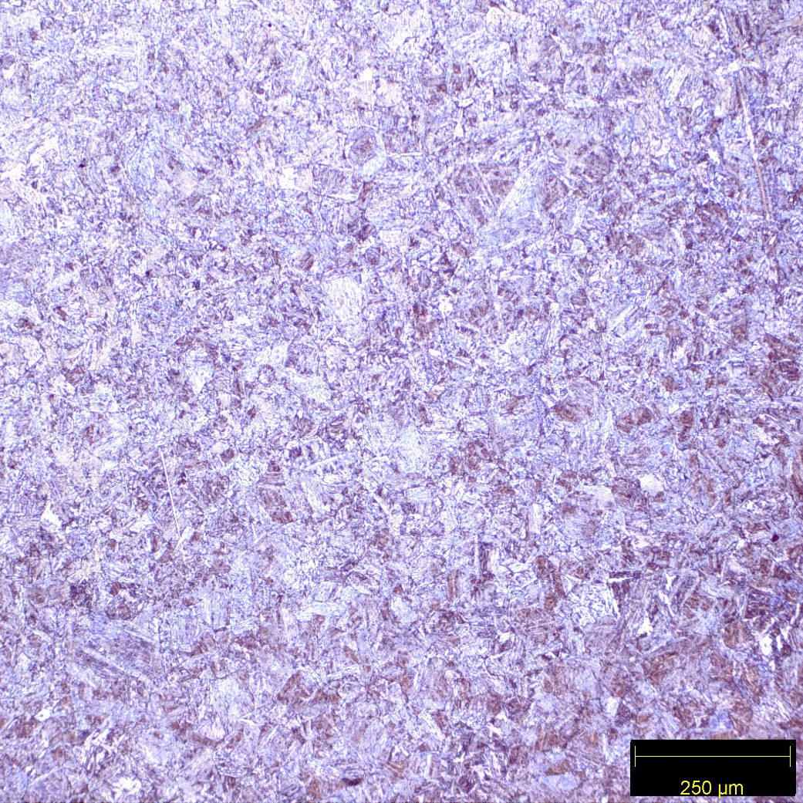

*Figure 7: 4340 air-cooled using the 10x objective.*

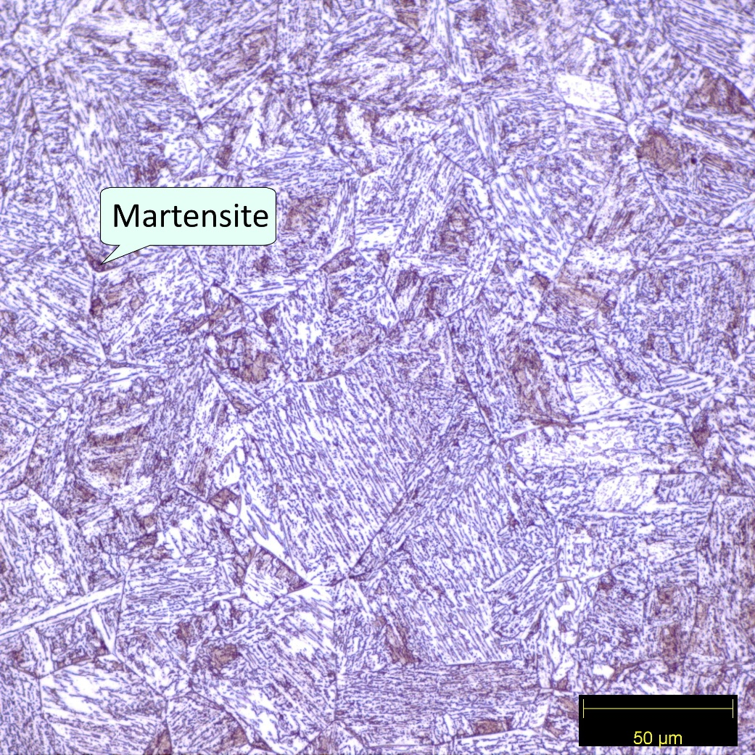

*Figure 8: 4340 air-cooled using the 50x objective. The dark color indicates martensite.*

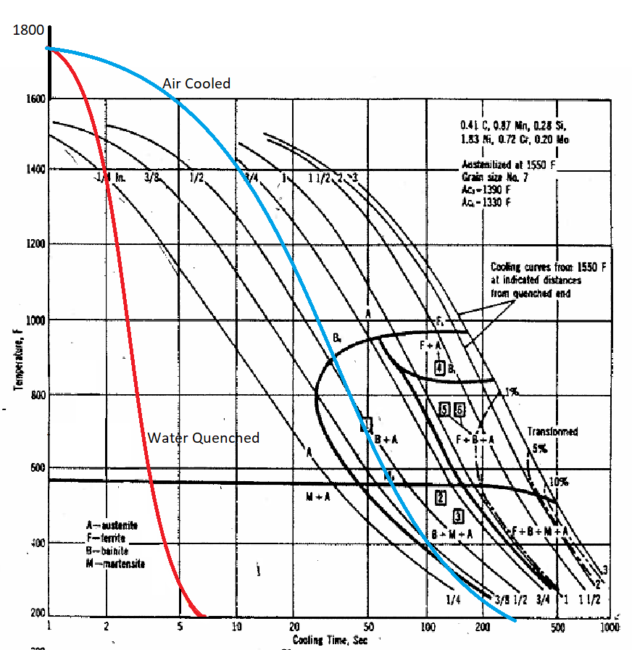

*Figure 9: CCT diagram for 4340 steel with constant cooling curves for air-cooled, quenched, and tempered samples.*

The micrographs for 4340 air-cooled show two distinct microstructures (Figure 7 and 8). The 4340 CCT with a 313 second cooling rate shows a final microstructure of bainite and martensite. The dark microstructure on the micrographs are martensite. The bainite cannot be differentiated from martensite on the micrograph, however it is present. The hardness data agrees with the micrograph and the 4340 CCT with a 313 second cooling rate, as the hardness is 29.7 Rockwell C (Figure 9 and Table 1).

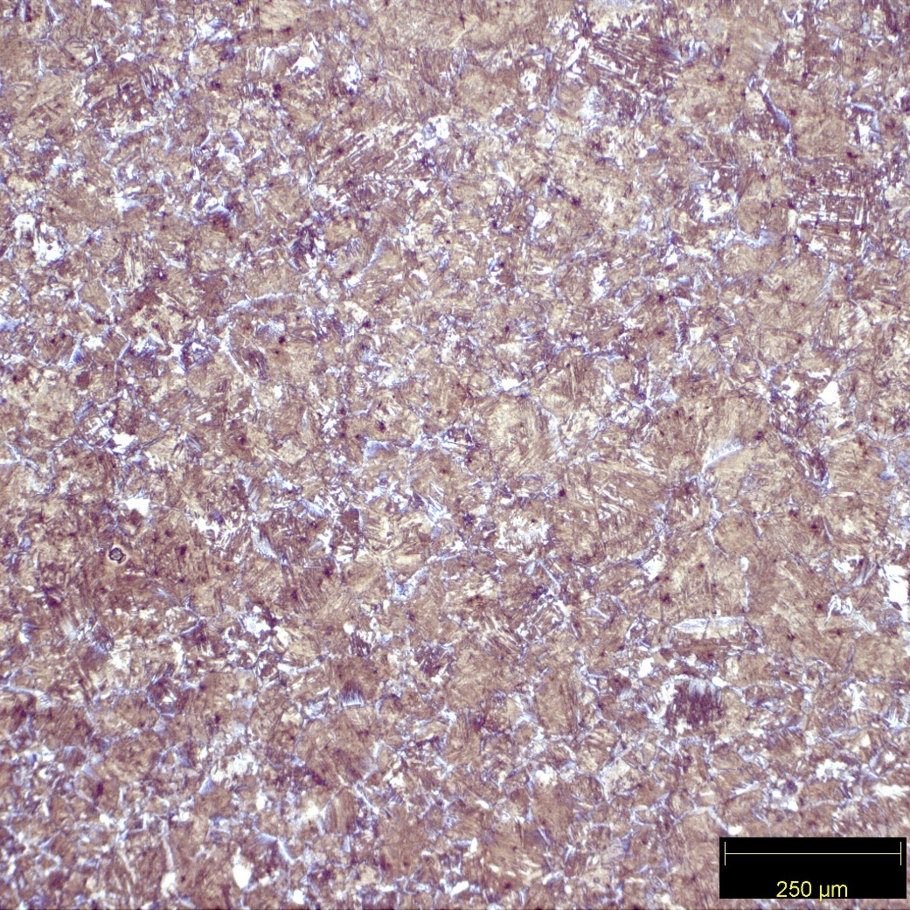

*Figure 10: 1018 water-quenched using the 10x objective.*

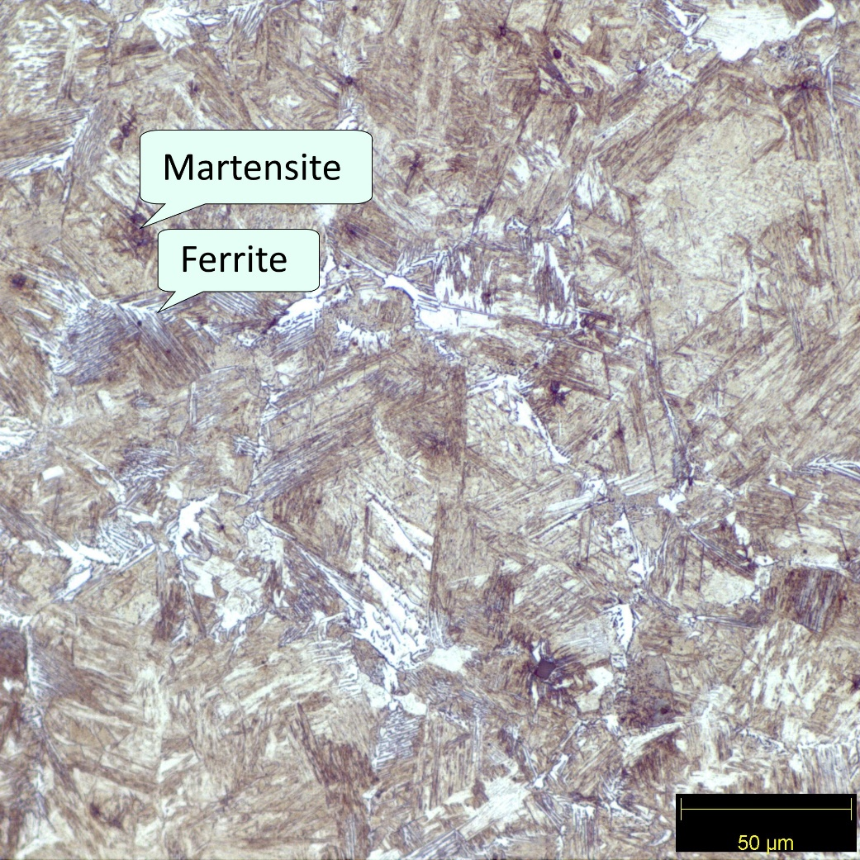

*Figure 11: 1018 water-quenched using the 50x objective. The light color indicates ferrite, and the dark color indicates Martensite.*

The water-quenched 1018 steel has a hardness of 27.5 Rockwell C, and the 1018 CCT diagram with a 6.8 second quench shows a predicted microstructure of ferrite, bainite and martensite (Table 1 and Figure 3). The dark colors in the micrograph indicate martensite (Figure 11). The light color indicates ferrite (Figure 11). There is bainite present, but it cannot be differentiated from martensite on the micrograph.

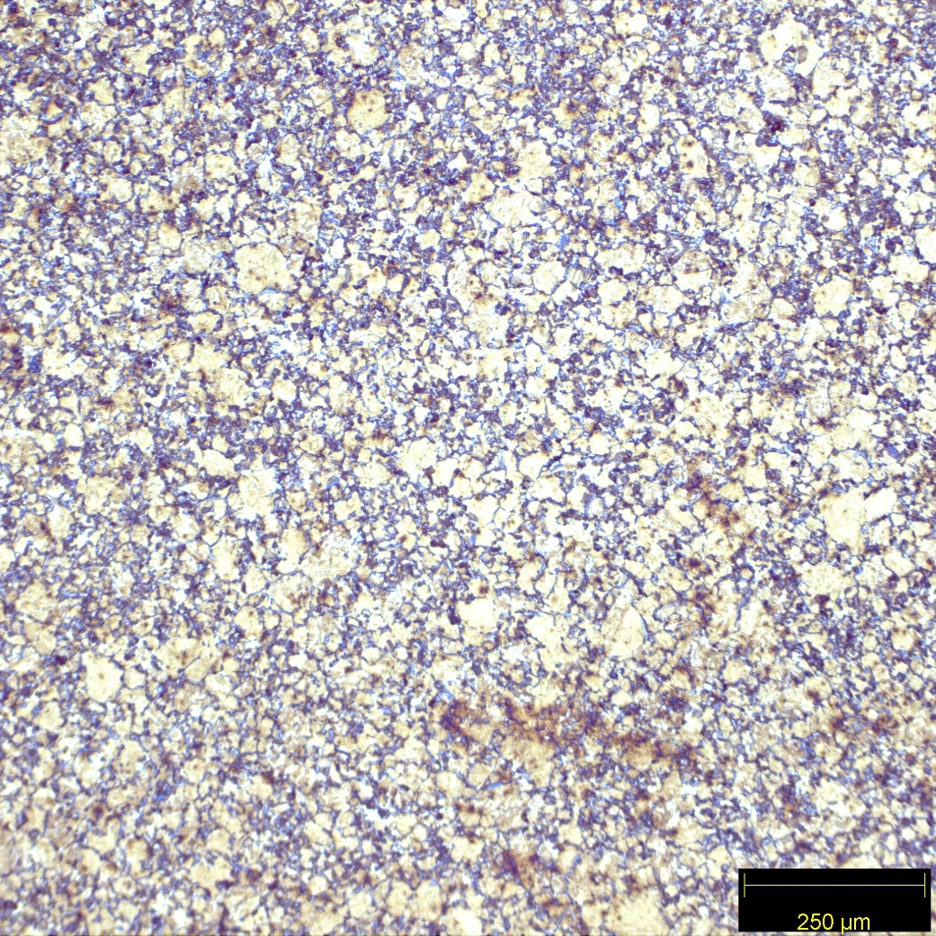

*Figure 12: 1045 water-quenched using the 10x objective.*

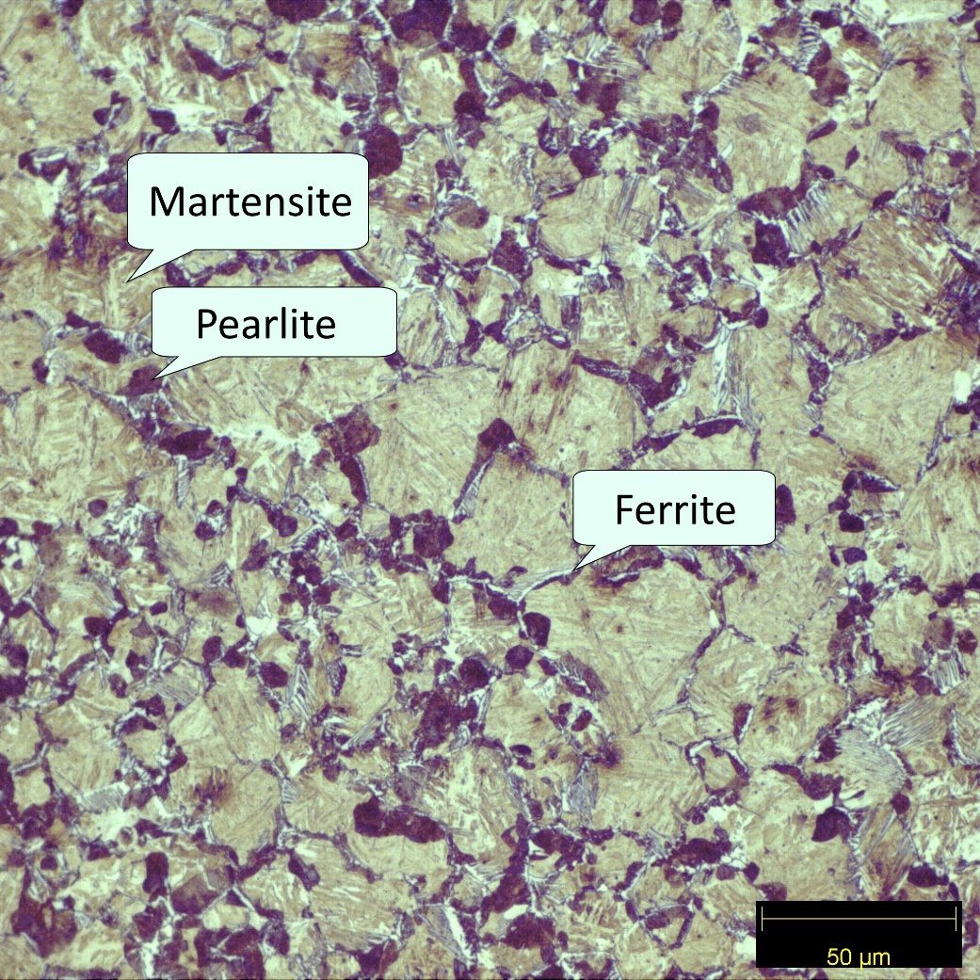

*Figure 13: 1045 water-quenched using the 50x objective. The light color indicates ferrite, the gray color indicates pearlite, and the dark color indicates pearlite.*

The 1045 water-quenched contains ferrite, pearlite, and martensite by reading the 1045 CCT diagram with a 313 second cooling rate (Figure 6). This is confirmed by looking at the 1045 water-quenched micrographs (Figures 12 and 13). The martensite is the light gray, the pearlite is the darkest spots, and the ferrite is the lightest portions that appear to look like old grain boundaries (Figure 13). This analysis is supported by the hardness being 40 Rockwell C (Table 1).

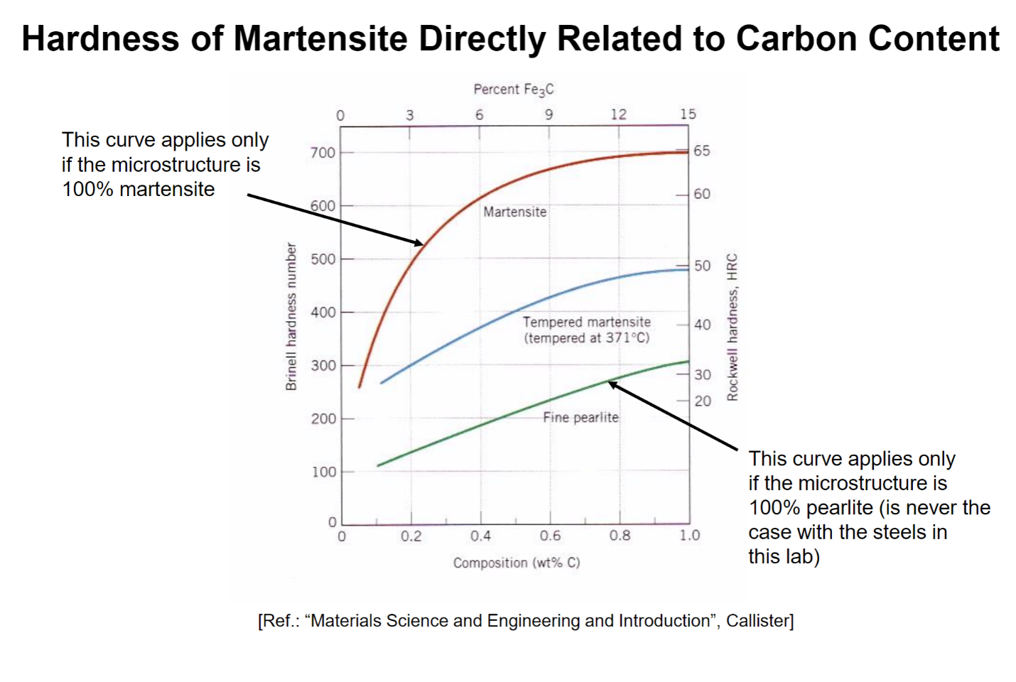

*Figure 14: Hardness of martensite directly related to carbon content.*

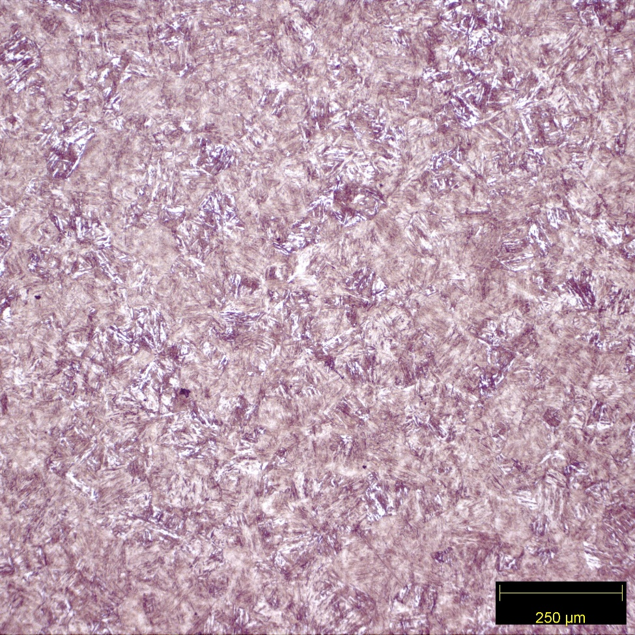

*Figure 15: 4340 water-quenched using the 10x objective.*

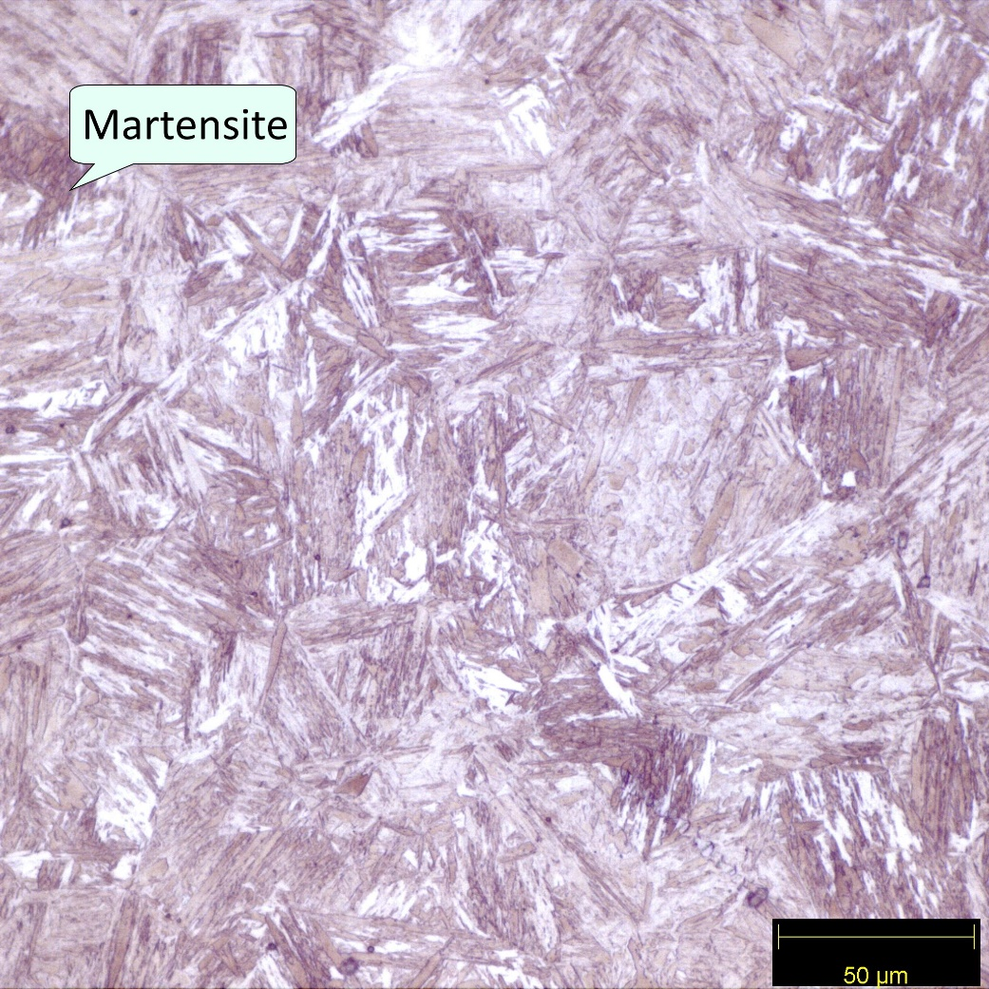

*Figure 16: 4340 water-quenched using the 50x objective. The dark color indicates martensite.*

Water-quenched 4340 should be 100% martensite with a hardness of 60 Rockwell C, however, it has a hardness of 40.2 Rockwell C (Figure 9 and 13, Table 1). This unexpectedly low hardness is explained by the presence of untransformed austenite in the metal (Figures 15 and 16. Martensite presents as the dark color in the micrograph (Figure 16).

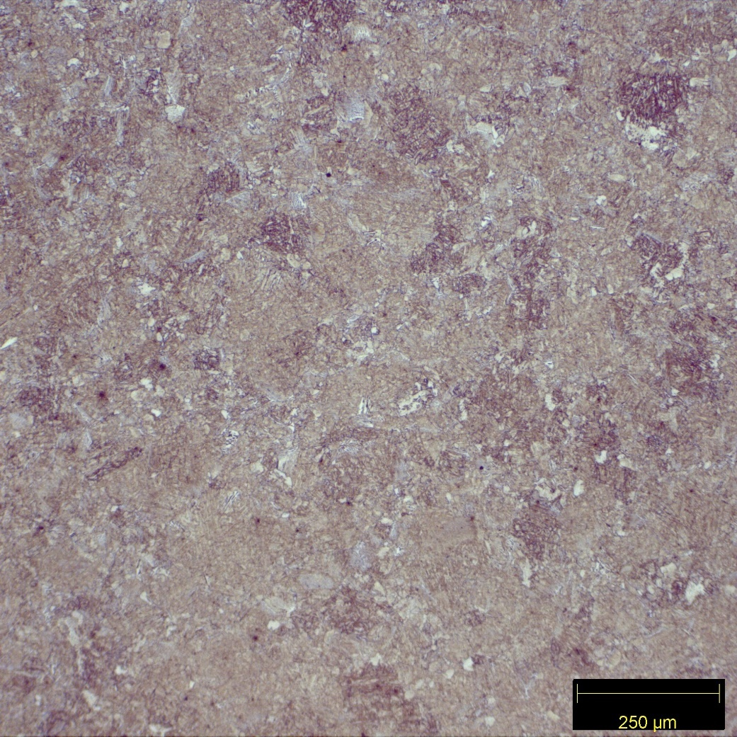

*Figure 17: 1018 tempered using the 10x objective.*

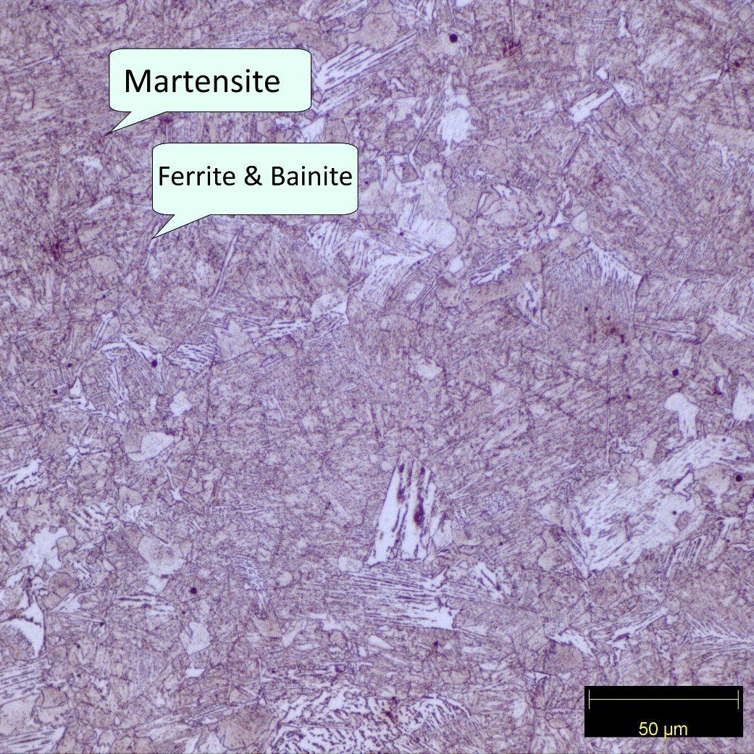

*Figure 18: 1018 tempered using the 50x objective. The light color indicates ferrite or bainite, and the dark color indicates martensite.*

The 1018 tempered has a hardness of 27.5 Rockwell C, and the 1018 CCT diagram with a 6.8 second quench shows ferrite, bainite and martensite forming, (Table 1 and Figure 3). The dark colors signify martensite. The light color in the micrograph is either ferrite or bainite (Figure 17 and 18).

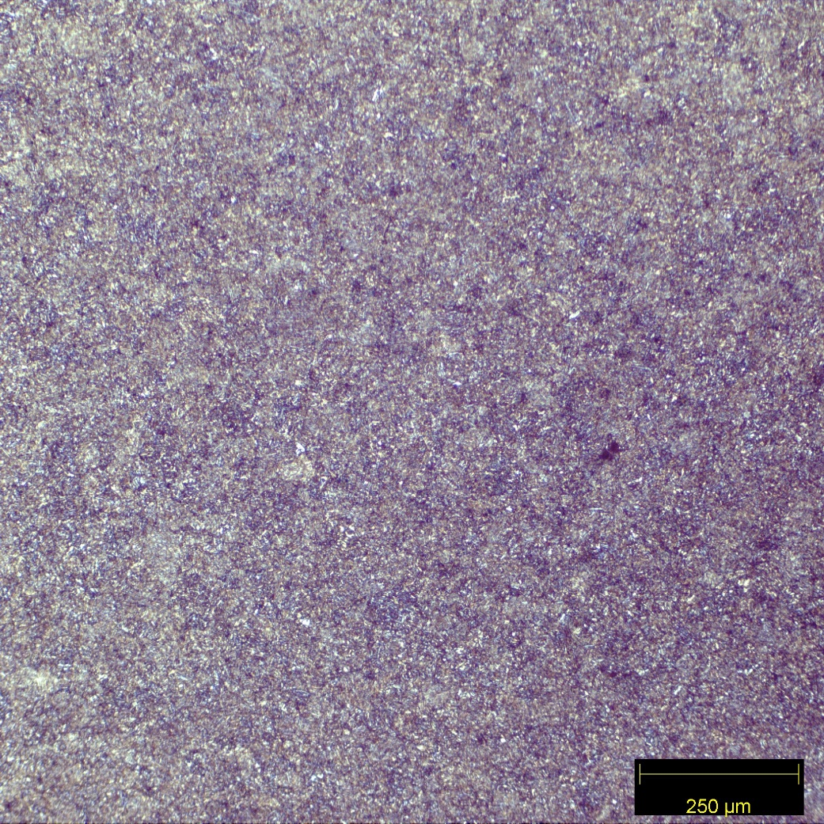

*Figure 19: 1045 tempered using the 10x objective.*

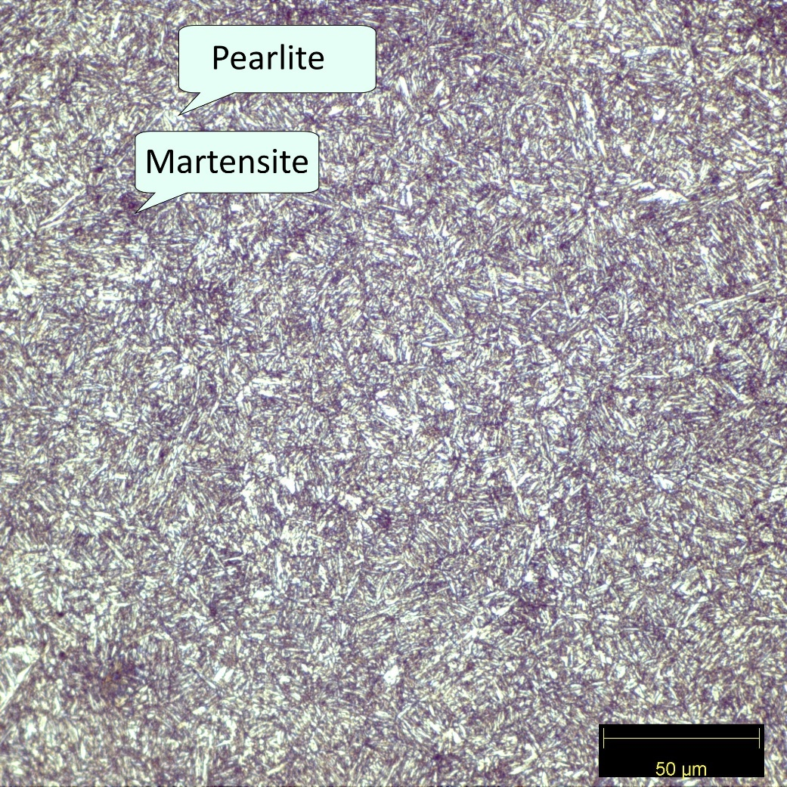

*Figure 20: 1045 tempered using the 50x objective. The light color indicates pearlite, and the dark color indicates Martensite.*

1045 tempered steel is predicted to have a microstructure consisting of martensite, pearlite and ferrite (Figure 6). Only martensite and pearlite were observed (Figures 19 and 20). The martensite was observed to be the dark portions of the micrograph, and the pearlite was observed to be in the light portions (Figure 20). Hardness was observed to be 27.7 Rockwell C (Table 1).

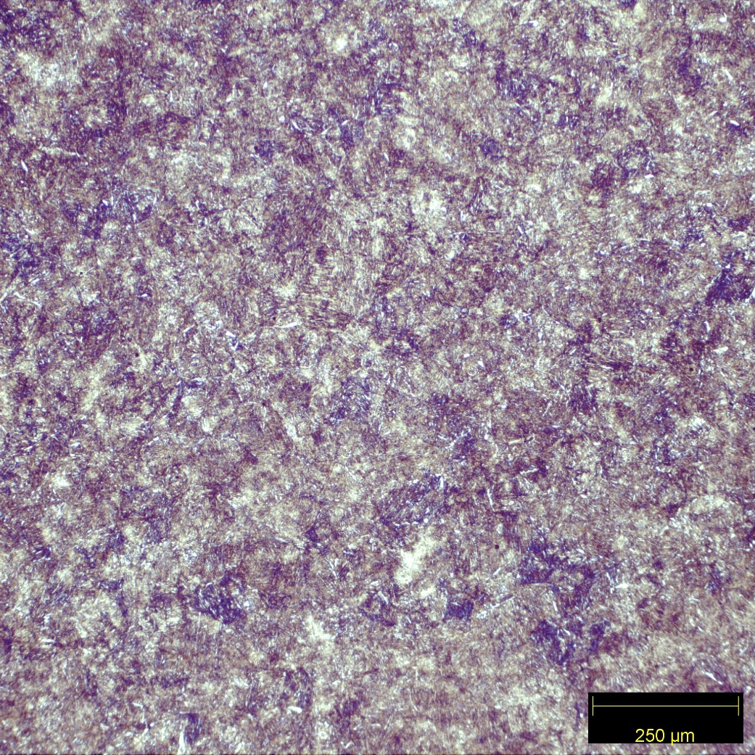

*Figure 21: 4340 tempered using the 10x objective.*

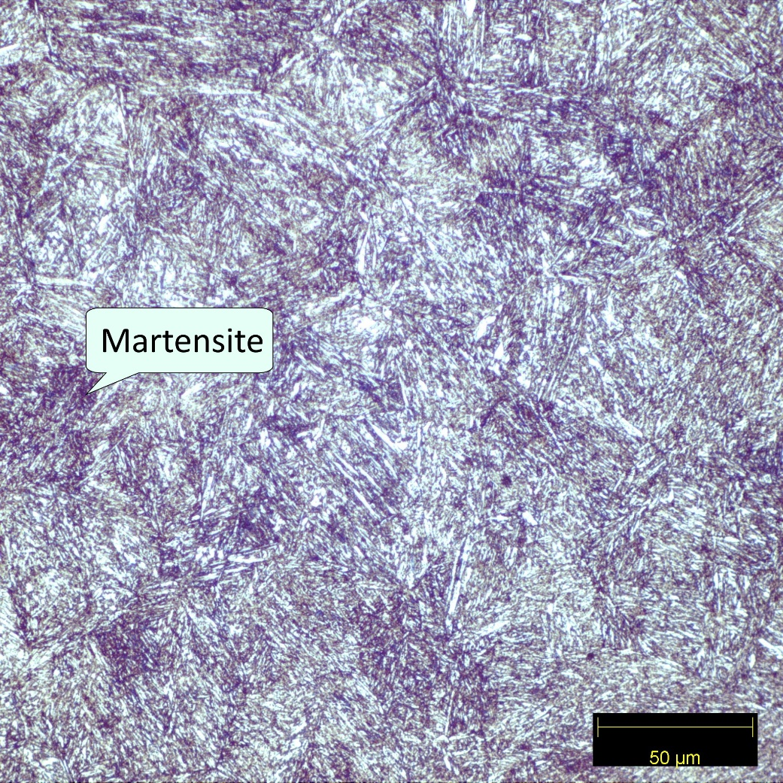

*Figure 22: 4340 tempered using the 50x objective. The dark color indicates martensite.*

The 4340 tempered sample has a hardness of 34.5 Rockwell C (Table 1). However, the 4340 CCT predicts 100% martensite and the hardness curve predicts a hardness of 40 (Figure 9). These numbers do not match, as there is untransformed austenite still in the sample (Figures 21 and 22). The martensite is the dark parts of the micrograph.

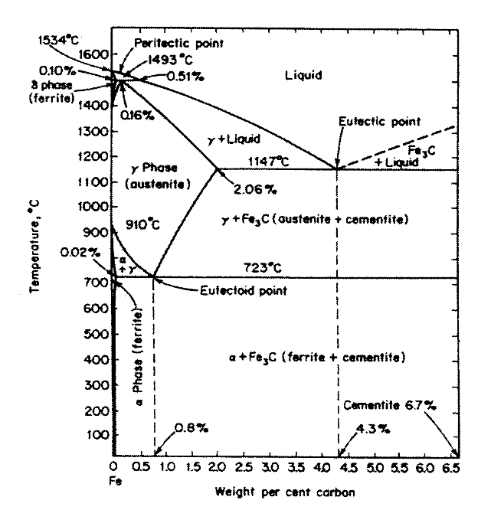

*Figure 23: Fe-Fe3C binary phase diagram.*

**Discussion**

The 1018 and 1045 air-cooled samples contain microstructures consisting of only ferrite and pearlite, however, despite experiencing the same cooling rate they have visibly different amounts of each microconstituent. 1018 air-cooled contains mostly ferrite and the 1045 air cooled contains mostly pearlite (Figures 2 and 4). This is due to their respective amounts of carbon content and cooling rate. Diffusion must take place to allow ferrite and pearlite to form, and the air cooling provides plenty of time for that. The more carbon a steel has in it, the less ferrite will form upon cooling, and the 1018 has 0.18 wt.%. and the 1045 has 0.45wt.%. This is why the 1018 and 1045 contain differing amounts of ferrite, despite cooling the same way (Figure 23). Alloying elements in the 4340 make diffusion more difficult, which is why the microstructures of 4340 and the 1045 appear so different despite being close to each other in carbon content (Figures 4 and 8). The macrohardness data for the air-cooled 1018, 1045, and 4340 are 68.5B, 88.2B and 29.7C respectively (Table 1). Since ferrite is the softest microstructure it makes sense that 1018 air-cooled is softer than the 1045 air-cooled. 4340 air-cooled is entirely made up of martensite and bainite, two much harder microstructures, so it is harder than the other two air-cooled samples.

Water-quenching does not allow nearly as much diffusion to happen as the time spent at high temperatures is far less with a quench time of 6.8 seconds. Ferrite formation is severely stunted as a result. Carbon can remain trapped in the microstructure, and as a result martensite will form in those places. 1018 water-quenched contains ferrite, bainite, and martensite (Figure 11). However, due to a higher carbon content the 1045 water-quenched contains even more, as more carbon failed to diffuse out of the grains in time ( Figure 13). The 4340 water-quenched sample should contain 100% martensite, but it’s hardness of 40.2C does not match up with its predicted hardness of 60C (Table 1 and Figure 14). This is due to the fast cooling rate preventing some of the austenite from transforming into martensite, causing the resulting hardness not to hit the predicted levels. The hardness for the water-cooled 1018, 1045, and 4340 is 27.5C, 40C, and 40.2C (Table 1). The 1045 is harder than the 1018 due to higher carbon content and therefore more carbon trapped in the BCT lattice structure of the martensite. The 4340 has slightly lower carbon content than the 1045, but still has about the same hardness after quenching (Table 1). This is due to alloying elements, and their impact on the microstructure.

Tempering serves to control the hardness of a steel. Once quenched, the steel is at a high hardness, but a low ductility. Depending on the desired properties of a steel, it may be tempered to bring back some of it’s ductility. The reheating up to a certain temperature allows for some of the carbon that is trapped in the martensite to escape and form carbides. These carbides are not picked up on the micrographs, but their impact can be seen in the hardness data. The trend is the same for all three tempered samples. 1045 water-cooled has a hardness of 40C, and 1045 tempered has a hardness of 27.7C (Table 1). 1018 tempered has a hardness of 94.3B compared to the 27.5C that 1018 water-cooled sample has. 4340 water-cooled has a hardness of 40.2C, and a tempered hardness of 34.5C. There is less carbon trapped in the BCT lattice structure of the martensite, causing a decrease in hardness. The alloying elements in the 4340 sample allowed tempering to have a diminished impact by slowing diffusion, with a drop of only 5.7C while the 1045 sample lost 10.3C during the tempering process.

The hardness and hardenability of steels of is an extremely important in welding. The steels get heated to extreme temperature temperatures in the heat-affected zone. Cooling from these temperatures causes different microstructures to form in the steel than what were there initially. In welding, the heat-affected zone cools quickly, and forms martensite, and more martensite forms in high carbon steels. As a result, as carbon content increases, so does hardenability. To prevent welds from becoming too brittle, once the welds are made, the work piece is slowly cooled to allow for carbon do diffuse out. More ferrite and pearlite forms as a result the weld has more ductility. The harder the steel, the higher the risk is for the weld to become too brittle upon cooling. This is not exactly true for hardenability of steels. 1018 steel is a prime example of this. 1018 has an air-cooled hardness of 68.5B, and a quenched hardness of 27.5C (Table 1). This would be desirable for welding, as the weld joint could be cooled without any post-weld heat treatments while not worrying about the weld becoming too brittle.

Hardness and hardenability are also important for the heat treatment of steels. Certain applications may demand a steel of a specific hardness, and a heat-treated steel may be the most economical choice over a more expensive one. An air-cooled 1045 has a hardness of 88.2B (Table 1). It can be water quenched to 40C (Table 1). An air cooled 4340 has a hardness of 29.7C and can be hardened to 40.2C (Table 1). The 1045 air-cooled is softer than the air-cooled 4340, but both reach the same hardness in a water quench. This may lead to a less expensive water-quenched 1045 being chosen for a project over 4340. If the project includes cyclical heating and cooling, the 4340 may be chosen due to its higher base hardness. Hardenability is the steels ability to change hardness due to cooling rates, and the hardness is how well the metal resists plastic flow. Both are important factors to think about when selecting a metal for a job, and many factors must be considered.

**Conclusion**

For each heat treatment the 1018 was softer than the 1045 (Table 1). This was due to the 1018 having less carbon, which leads to more ferrite in the air-cooled samples and less martensite in the water-quenched and tempered samples. Despite having lower carbon content, the 4340 samples were harder than the 1045 in both the air-cooling and tempering heat treatments (Table 1). The 4340 and 1045 have a difference of 0.2wt.%C for the water quench with the 4340 slightly ahead (Table 1). This is due to the alloying elements in the 4340 suppressing the formation of pearlite and ferrite. As a result, the air-cooled hardness of 4340 is higher than 1045, but 1045 has a higher hardenability overall (Table 1).

The air-cooled samples for both the 1018 and 1045 had 313 seconds to cool, and in that time, diffusion had ample time to take place. This resulted in a microstructure of ferrite and pearlite (Figures 2 and 5). The 1018 had more ferrite due to lower amounts of carbon, and the 1045 had more pearlite due to higher carbon contents. The 4340 air-cooled had only bainite and martensite due to effects of the alloying elements on the formation of ferrite and pearlite (Figure 7).

The water-cooled sample of 1018 contained martensite, pearlite, and ferrite (Figure11). Water-cooled 1045 had martensite and pearlite present (Figure 12). Due to higher amounts of trapped carbon in the martensite the 1045 was harder the 1018 sample (Table 1). The 4340 water-cooled sample was partially martensite and partially untransformed austenite. The 4340 water-cooled was roughly the same hardness as 1045 water-quenched, with the 4340 at 40.2C and the 1045 at 40C (Table 1).

The tempered samples all had the same microstructure as their water-quenched counterparts based on their 1018, 1045, and 4340 CCT diagrams (Figures 3, 6 and 9). However, the hardness of each was lower than their water-quenched counterparts due to the extra diffusion of carbon out of any present martensite while at 450°C for 15 minutes (Table 1).